Graphic Design A2 Summer project 2016

Task: Design a set of ICONS connected to your chosen unit 3 theme.
These will be used as ‘chapter breaks’ or as page numbers on your work.
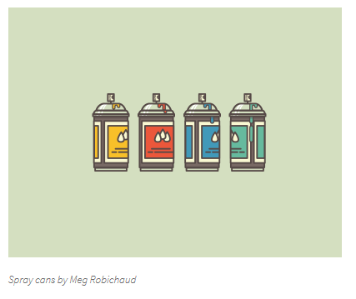
For instance:
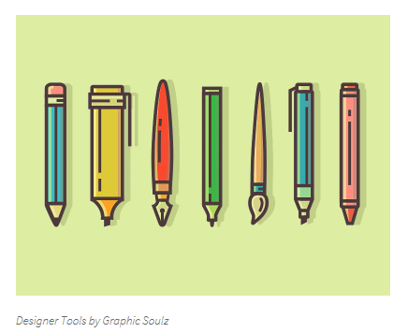
Next:
Design a business card and letter head for your freelance graphic design skills. Make them clever.
Next:
Design a poster for a charity of your choice. Their logo must remain the same, but the rest is up to you, for instance:
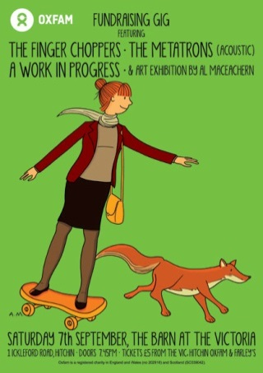
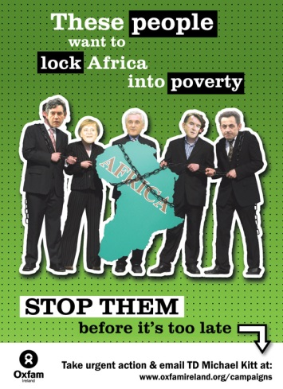
These tasks are designed to be open-ended: They allow you to build them into hefty design research solutions or standalone projects. Your choice. You will show these, in addition to the work you have developed on your Unit 3 independent study and dissertation work on the first formal lesson in September.

